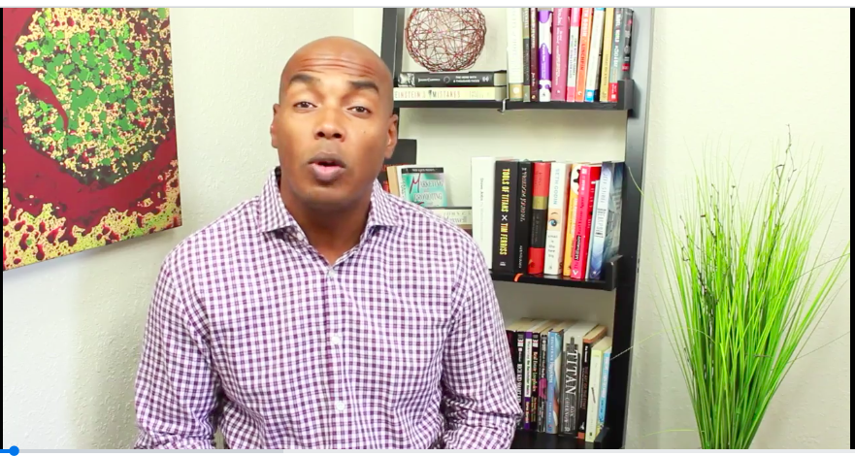
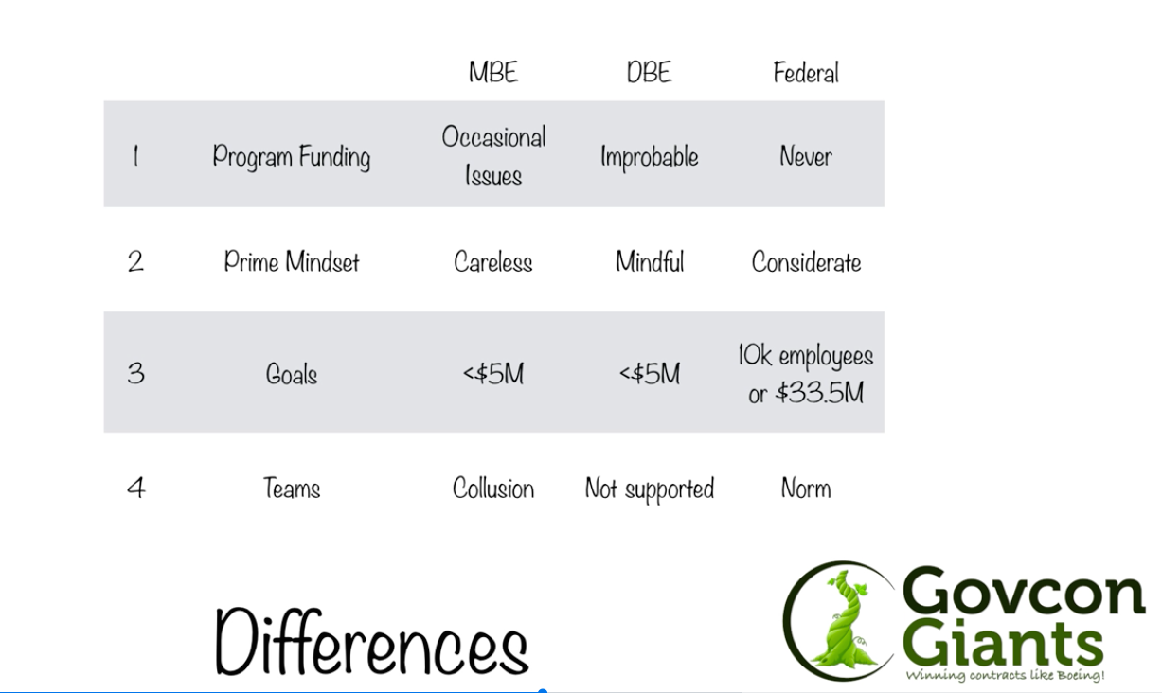
Day #1 – INTRODUCTION TO THE WORLD OF GOVCON
-----------------------
Welcome to " GovCon Giants!" Day #1

Over the next 12 days I'm going to be sending you a video each day that will walk you through the serious of steps you need to land a government contract in the federal arena.

We normally sell this training video for $497 - but you're getting it for free because I know that if you implement this training, and do the assignments each day, then in less than 90 days from now you'll be bidding and evaluating potential federal contracts ... a HUGE win for you.

And if you start winning government contracts then you'll become a HUGE ScoreContracts fan and spread the word which is BIG win for US!

ASSIGNMENT #1 - WATCH

ASSIGNMENT /HOMEWORK
-----------------------

Start Here:
What is a federal contract? (keynote)

How does it differ from any other contracts?

Homework:
Research a national organization that you can join to help you expand your contacts in the government marketplace. Here’s a quick video of some of the benefits.

Spend a few hours researching national organizations that support federal contracting. This post lists 15 organizations to consider.

Or get your FREE copy of my book, Billion Dollar Playbook that lists out 20+ organizations plus provides descriptions for each one.

If you have any questions or are confused about a topic please click the Question button and someone will respond.

Complete Assignment #1 below

QUESTION

